AUTOMATING FINAL EXAM FAIRNESS: A DEEP LEARNING APPROACH TO ALIGN QUESTIONS WITH BLOOM’S TAXONOMY AND LEARNING OUTCOMES

Research Project Proposal
presented to the Faculty of Computing
NSBM Green University
in partial fulfillment of the requirements for the degree of
BSc (Honours) in Software Engineering

By

December 2025
Table of Contents
Contents
1. Introduction 3
1.1 Background of the Study 3
1.2 Motivation 3
1.3 Study Objective 4
2. Literature Review and Research Gap 5
2.1 Overview of Existing Studies 5
2.2 Identification of Research Gap 7
3. Research Problem and Questions 8
3.1 Main Research Problem 8
3.2 Specific Research Questions 8
4. Research Strategy and Methodology 10
4.1 Research Strategy 10
4.2 Research Methodology Framework 10
4.3 Data Collection Methods 17
4.4 Data Preprocessing / Preparation 18
4.5 Model Development / Implementation 18
4.6 Evaluation 20
4.7 Ethical considerations 21
4.8 Limitations of the study 23
5.Timeline 24
References 25

1. Introduction

1.1 Background of the Study
The rapid digital transformation of higher education has shifted the focus from simple content delivery to Outcome-Based Education (OBE). In this framework, the "Constructive Alignment" between Intended Learning Outcomes (ILOs) and assessment tasks is the primary metric of academic quality. According to Revised Bloom’s Taxonomy, cognitive development is a hierarchy ranging from lower-order skills, such as Remembering, to higher-order skills, such as Evaluating and Creating.
Currently, educational institutions rely on manual auditing processes to ensure that exam papers accurately reflect the complexity promised in the syllabus. This process involves subject matter experts manually tagging questions with Bloom’s levels—a task that is labor-intensive, time-consuming, and highly susceptible to subjective bias. Existing technologies in Natural Language Processing (NLP) have attempted to automate this using keyword matching; however, these traditional methods fail to capture the semantic context of pedagogical verbs. As a result, there is a growing need for sophisticated Deep Learning architectures, such as Bidirectional Long Short-Term Memory (Bi-LSTM) networks, coupled with structured data models like Knowledge Graphs, to provide a rigorous and automated validation of assessment fairness.

1.2 Motivation
The motivation for this research stems from the widening "Cognitive Gap" in modern assessments. Despite syllabi claiming to foster critical thinking, final examinations often default to rote-memorization tasks because they are easier to design and grade. This "Surface Learning" assessment style creates a social and academic injustice, where students are not evaluated on the high-level skills required by the global labor market.
Personally, and academically, I am inspired by the potential of Artificial Intelligence to act as a "pedagogical guardrail." By creating a system that can objectively flag a question paper as "High Risk" or "Unfair" before it reaches the student, we can protect the integrity of the degree and ensure that educational promises are kept. Furthermore, the technical challenge of integrating sequential deep learning (Bi-LSTM) with relational structural data (Knowledge Graphs) represents a significant frontier in Educational Data Science that offers a unique opportunity to improve teaching-learning productivity.

1.3 Study Objective
1.3.1 Primary Objective
- To develop an automated, AI-driven framework that evaluates the fairness and constructive alignment of final exam question papers against modular learning outcomes using the Revised Bloom’s Taxonomy.

1.3.2 Secondary Objectives
- To implement a robust data extraction and pre-processing pipeline using Pytesseract (OCR) and SpaCy to digitize and clean unstructured educational documents.
- To design and train a Bidirectional LSTM (Bi-LSTM) architecture capable of high-accuracy classification of exam questions by capturing the bidirectional semantic context of pedagogical verbs.
- To construct a Syllabus Knowledge Graph using Neo4j that maps the logical dependencies between modules, lesson learning outcomes, and required cognitive levels.
- To develop an Automated Fairness Audit Engine that generates real-time "Fairness Scorecards" and warnings for educators, identifying misalignments between predicted cognitive levels and syllabus requirements.

2. Literature Review and Research Gap

2.1 Overview of Existing Studies
Constructive Alignment is a relevant notion that promotes academic excellence in higher education institutions. This notion was proposed by Biggs [1]. It describes how learning activities and assessment tasks can be designed in a way that meets the Intended Learning Outcomes (ILOs) of a module. To incorporate the outcomes into categories, Bloom’s Taxonomy is applied. It stratifies the ordering of cognitive abilities beginning with lower-order thinking abilities (LOTS) like Remembering through higher-order thinking abilities (HOTS) like Evaluating and Creating [2].
According to recent research carried out by Ramya Kumar et al. [3], lack of alignment between the assessment outcomes and the expected level of cognition in the course creates conditions under which the student settles for surface learning. In these circumstances, the learners rely entirely on memorization as opposed to comprehension. This misalignment causes a cognitive gap that hampers the process of teaching and learning. Consequently, there is an emphasis put on automated procedures by the paper that can work towards reinforcing constructive alignment in higher learning institutions.
While reviewing previous studies on evaluating examination question papers, several important findings were identified. The analysis of cognitive levels shows that there are many good practices where examination questions are properly aligned with the required learning outcomes [4]. Apart from Bloom’s Taxonomy, other classification methods have also been used in different studies.
Some researchers have applied an ontology-driven framework to assess the fairness of question papers. In this approach, keywords are extracted from each question and mapped to nodes in a syllabus ontology. Based on the level of syllabus coverage, a model was developed to calculate the fairness of the question paper. One study selected the Data Mining subject from Semester VII of the final-year Computer Engineering program at Mumbai University. In this ontology, each node represents a concept or topic from the syllabus and carries the same name as the syllabus topic. The subject name acts as the root of the ontology tree, while major topics such as classification, clustering, web mining, and association rule mining form the level 1 nodes [5]. Each major topic is assigned a weight based on the number of lecture hours allocated to it.
The general process used to assess fairness is divided into three main steps: identifying keywords from the questions, mapping these keywords to the syllabus ontology, and computing syllabus coverage. The main idea is to use ontology to represent domain knowledge, extract concepts from natural language questions, and map them correctly to the ontology. Most researchers follow a similar system design that includes preprocessing, feature extraction, classification, and result combination.
Text mining techniques have been widely used to extract keywords from question papers and syllabus documents. These extracted keywords are then used in similarity coefficient–based comparisons between open-ended examination questions and the university-prescribed syllabus file. A syllabus provides guidance on planning semester activities, evaluating student performance, and allocating time and resources for learning areas that need improvement. The structure of a syllabus varies depending on the course, but it also serves as a model of professional thinking and academic writing for students [5].
Cosine Similarity Coefficient has been commonly used to assign similarity scores between question vectors and syllabus vectors. This method measures similarity by calculating the cosine of the angle between two vectors. A value of 1.0 indicates identical vectors, while values between 0.0 and 1.0 represent partial or no similarity. Cosine similarity is widely preferred due to its simplicity, ease of computation, and independence from document length [5].
Natural Language Processing (NLP) techniques have also been applied in these studies, including tokenization, stemming, tagging, lemmatization, chunking, and parse generation. Tokenization treats all words as strings and separates them into individual terms [ [5], [6]]. Stemming removes word endings using heuristic methods, while lemmatization, particularly using the WordNet Lemmatizer, identifies valid root words. Lemmatization is more effective than stemming, especially when identifying verbs, and is often applied before tagging [6].
To calculate the weight of syllabus terms, the tf-idf weighting method has been used. Tf-idf is a commonly used technique to assign importance scores to terms based on their frequency in both question papers and syllabus content. Each weight is calculated as the product of term frequency (tf) and inverse document frequency (idf). Higher idf values indicate terms that uniquely characterize a question within a unit [7]. Some studies used custom algorithms [7], ontology-based weightage methods [5], and Bloom’s Taxonomy [6] to measure these weights.
Research also shows that tools such as Microsoft Visual Basic .NET were used for front-end development, while SQL Server was used as the back-end database. Most studies selected IT-related university subjects, such as Software Engineering, as their datasets [ [5], [7], [6]]. Following standard learning outcomes provides benefits to both students and teachers. Students gain a clear understanding of what they are expected to learn, teachers are guided in designing effective teaching materials, and assessments and evaluations can be developed more accurately.
The system implementations were typically tested using back-end tools on a 2 GHz processor with 1 GB RAM as the required software and hardware configuration.
Automated Classification of Bloom’s Taxonomy has been achieved in three technical stages.
In this stage, rule-based systems were employed for question classification. The rule-based systems were reliant on keyword searching and Part-of-Speech (POS) tagging for searching action verbs like “Describe” and “Analyze.” Although this method is quite efficient and has less complexity for implementation, this method fails to extract the semantic meaning behind questions asked. It has limitations in grasping the context where the verb is utilized.
Later on, machine learning methods were employed to increase the results of the classification process. Traditional machine learning algorithms like SVM and Naive Bayes employed TF-IDF techniques to feature the texts. Although traditional methods were more accurate than rule-based systems, Febriyana noted in [8] that they have problems with the word-order problem. This problem happens because different cognitive levels are portrayed by the same action verb depending on the use of the verb in the sentence.

Later research work has progressed into more Deep Learning (DL) techniques. Some of these models include Recurrent Neural Networks (RNNs), which utilize the Transformer models, also used within the classification of Bloom’s Taxonomy. Of these, Long Short-Term Memory (LSTM) networks, particularly Bidirectional LSTMs (Bi-LSTMs), have emerged with improved performance skills. Bi-LSTMs read the input data from both the forward and reverse perspectives, hence gaining insights into the overall structure of the query statement. Consequently, this enables the model to grasp the learning objective of the query statement by identifying the linkage between the first action verb and the complexity of subject matter towards the end of the statement, as highlighted by Banujan et al. [9].

2.2 Identification of Research Gap
In the question paper lecturers must cover the defined module learning outcomes specific to the final question paper. When creating question papers according to the bloom’s taxonomy difficult problems occur. Bloom’s taxonomy levels should spread as the moderator expects. In one component of "Evaluating teaching content and assessments based on learning outcomes (Kumari et al., 2020)" research paper, check the percentage of the coverage on bloom's taxonomy levels in question paper. There is over 50% of accuracy in that system.[10]. In my research, improving above, I intend to design a system capable of analyzing learning outcomes for modules and lessons based on Revised Bloom’s Taxonomy. The system will also be able to determine whether there is alignment between Module learning outcomes and Final exam paper using the LSTM to report a higher accuracy level.
In this section, I have summarized some literature and some gaps in those research works which will be addressed by my design.
- Research 01 - Ontology Driven Framework for Assessing the Syllabus Fairness of a Question Paper [5]
- Research 02 - A Syllabus-Fairness Measure for Evaluating Open-Ended Questions [6]
- Research 03 - WordNet and Cosine Similarity-based Classifier of Exam Questions using Bloom’s Taxonomy [7]
- Research 04 – Evaluating Teaching Content and Assessments based on Learning Outcomes [10]
- Research 05 – "Automated Evaluation Systems to Enhance Exam Quality and Reduce Test Anxiety" (PMC, Feb 2025)[9]

Table 1: Comparison of existing researches and our proposed system
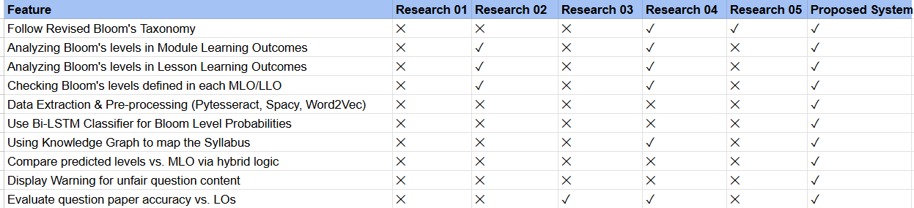

3. Research Problem and Questions

3.1 Main Research Problem
There was no standardized, automatic way to verify the constructive alignment between the questions being used in the final exam questions and the intended learning outcomes, resulting in "cognitive drift" assessment questions not reflecting the scope of the syllabus that was being defined.

3.2 Specific Research Questions
1. How can the "Cognitive Gap" between promised learning outcomes and actual exam content be quantified and visualized for educators?
- The Issue: Many assessments suffer from "Surface Learning Bias," where questions focus on lower-order thinking (Bloom’s Levels 1-2) despite the syllabus requiring higher-order analysis or evaluation (Levels 4-6).

- Proposed Solution: The study addresses this by developing a Fairness Scorecard and a Cognitive Distribution Chart that provides an instant visual comparison between the intended syllabus levels and the actual exam levels detected by AI.

2. To what extent can a Bidirectional LSTM (Bi-LSTM) improve the classification accuracy of pedagogical verbs compared to traditional keyword-matching techniques?
- The Issue: Traditional systems struggle with context. For example, the word "State" in "State the law of gravity" (Level 1) vs. "State the implications of your findings" (Level 4) is often misclassified.

- Proposed Solution: By utilizing a Bi-LSTM architecture, the system will process exam questions in both forward and backward directions, capturing the relationship between the initial action verb and the complexity of the succeeding noun phrases to ensure high-precision mapping to the Revised Bloom’s Taxonomy.
3. How can a Knowledge Graph be utilized to detect structural "Dependency Gaps" and "Out-of-Bounds" content in a modularized syllabus?
- The Issue: Current automated systems treat syllabi as linear text, failing to recognize that certain advanced modules have strict lower-level prerequisites.

- Proposed Solution: This research implements a Neo4j-based Syllabus Knowledge Graph. This allows the system to verify that questions are not only at the right Bloom level but also map to the correct module and that no "out-of-bounds" topics (content not in the syllabus) are included in the final assessment.
4. What is the effectiveness of a hybrid OCR-Deep Learning pipeline in processing unstructured educational documents for real-time pedagogical auditing?
- The Issue: Most exam papers and syllabi are stored as PDFs or images, making them "dark data" that traditional NLP models cannot read directly.

- Proposed Solution: The study will integrate Pytesseract (OCR) with SpaCy for pre-processing and Word2Vec for embedding, creating a seamless pipeline that converts raw document images into structured, actionable pedagogical data.

4. Research Strategy and Methodology

4.1 Research Strategy
- In this study, the strategy employed is that of Design Science Research (DSR). The rationale for selecting this approach to research is that the main purpose of this research effort is to develop an "artifact," which is Automated Pedagogical Fairness Auditing System, with a view to solving a "problem" in educational assessment practices at UOWD, which can be addressed with a view to closing the "cognitive gap" that exists in constructive alignment theory.

4.2 Research Methodology Framework
- Problem Identification
The Challenge of Manual Pedagogical Auditing
Currently, the checking of final exam papers to see whether these align with the ILOs of a syllabus is still performed mainly manually. Faculty members or internal quality assurance teams go through each question to determine its cognitive level based on the Revised Bloom's Taxonomy. There are a number of serious drawbacks in this traditional approach,
- Subjectivity and bias: The action verbs in Bloom's taxonomy are perceived differently by different auditors. For example, the verb "State" may be seen as 'Remember' or 'Analyze', given the context, by different reviewers. This leads to the possibility of unequal evaluation standards (Shaikh et al., 2021).

- Manual Nature: In large departments with a number of modules, the reviewing of all examination papers is labor-intensive and subject to short cuts, such as "rubber-stamping," where papers are approved without properly evaluating cognitive quality.

- Cognitive Drift: It shows a general trend in higher education towards "Surface Learning". Courses that claim to teach higher-order thinking skills-like for example, Evaluation, Level 5-produce exams dominated by lower-level recall questions (Level 1). As this might never be detected without automated means, it is not fair on those students who prepared for higher-order tasks.

1.3 Motivation for the Proposed Artifact
- The need for this research is to transition from Passive Classification to Active Fairness Auditing. Through the integration of Bidirectional LSTM (Bi-LSTM) technology, which comprehends the entire meaning of a question, and the Knowledge Graph, which comprehends the logic behind the syllabus, this research proposes a "Self-Healing" curriculum solution. This solution will endow teachers with the ability to monitor and fix "Fairness Gaps" in a live setting, safeguarding the validity of this academic qualification and making sure that students are being tested on precisely what they paid for.

- Define Objectives
The overall objective of this research is the design of an intelligent auditing framework that automates the verification of constructive alignment in higher education assessments. Precisely, the objective is to:
2.1 Technical Objectives (The Artifact's Performance)
- Context-Aware Cognitive Classification: Go beyond simple keyword matching using a Bidirectional LSTM (Bi-LSTM) architecture. The goal is to achieve a classification accuracy of ≥ 85 % on all six levels of Revised Bloom's Taxonomy by capturing the semantic relationship between pedagogical action verbs and their preceding/succeeding noun phrases.

- Structural Alignment via Knowledge Representation: To design a Neo4j-based Syllabus Knowledge Graph that models relational dependencies among course modules, lesson outcomes, and cognitive requirements. The aim here will be to facilitate "Logical Validation" so that every exam question maps to a valid node in the syllabus and does not exceed the "Cognitive Ceiling" as set out in the curriculum.

- High-Fidelity Document Ingestion: Provide a robust pre-processing pipeline on Pytesseract OCR and SpaCy to extract text from unstructured PDF exam papers to a character-level accuracy good enough for downstream Deep Learning classification.

2.2 Functional Objectives (The Artifact's Utility)
- Automated Fairness Scoring: Based on the development of a "Fairness Index" algorithm that computes for each exam paper a quantitative score between 0 and 100%. This index will correspond to the statistical correlation between the exam's cognitive distribution and the syllabus's intended distribution.

- Real-time Conflict Detection: To provide a "Warning System" for educators, which flags "Out-of-Bounds" questions (topics not in the syllabus) and "Alignment Gaps" such as Level 5 Outcome being tested with only Level 1 Questions.

- Explainable Pedagogical Feedback: The system should be not a "black box" by giving visual justifications, in a way that XAI principles provide showing which particular keywords or graph relationships triggered a "Fairness Warning."
2.3 Comparison Objectives[Presentation: Benchmarking]
- Improvement in Efficiency: Reduce the preparation time for a standard departmental exam audit by at least 70% compared to manual expert review.

- Reliability Enhancement: Reduce human subjectivity by providing standardized, data-driven "Ground Truth" for Bloom's classification that can be consistently applied across academic terms and instructors.

- Design and Development
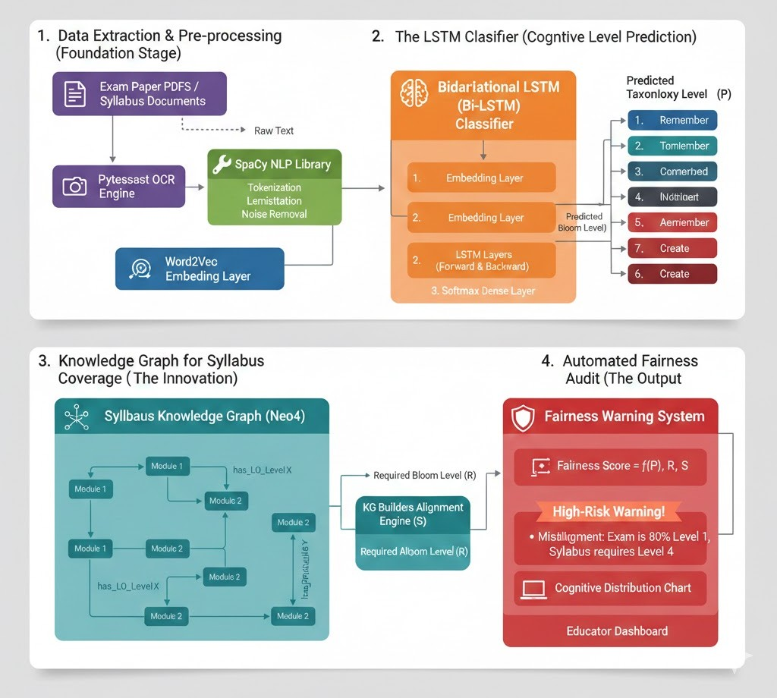

The proposed system is designed as a multi-layered hybrid pipeline that integrates optical character recognition, deep learning classification, and graph-based structural analysis.
3.1 Artifact Architecture and Functionality
The artifact consists of four primary functional modules that transform raw educational documents into a quantifiable fairness audit.

Module 1: Document Digestion & Pre-processing
The first layer utilizes Pytesseract (OCR) to handle the ingestion of diverse document formats (PDFs and Images). Once the raw text is extracted, SpaCy is employed for linguistic refinement, including:
- Tokenization and Lemmatization: Reducing pedagogical verbs (e.g., "analyzing," "analyzed") to their root form ("analyze") to ensure consistency.

- Semantic Vectorization: Utilizing Word2Vec embeddings to represent words as high-dimensional vectors, ensuring the model understands that "summarize" is semantically related to "paraphrase."
Module 2: Cognitive Classification (Bi-LSTM Layer)
The core of the intelligence layer is a Bidirectional Long Short-Term Memory (Bi-LSTM) network.
- Design Rationale: Unlike unidirectional models, the Bi-LSTM captures the sequential context from both the beginning (action verb) and the end (object complexity) of a question.

- Implementation: The model is structured with an Embedding Layer, followed by Hidden Bi-LSTM Layers, and a final Softmax Activation Layer to output a probability distribution across the six levels of the Revised Bloom’s Taxonomy.
Module 3: Syllabus Knowledge Graph Construction
To move beyond simple classification, the system builds a Knowledge Graph (KG) using Neo4j.
- Nodes: Represent Syllabus Units, Topics, and Learning Outcomes.
- Edges: Define "Has_Outcome" or "Prerequisite_Of" relationships.
This graph serves as the "Ground Truth" or the structural standard against which the exam paper is compared.
Module 4: Fairness Auditing & Warning Engine
The final module performs the Alignment Audit. It calculates a Fairness Index ($F$) by comparing the predicted Bloom levels from Module 2 with the required levels stored in the Knowledge Graph from Module 3.

3.2 Technical Specifications
The development of this artifact will utilize the following stack:
- Programming Language: Python 3.x
- NLP Libraries: SpaCy, NLTK
- Deep Learning Framework: TensorFlow / Keras (for Bi-LSTM)
- Graph Database: Neo4j
- OCR Engine: Pytesseract

- Demonstration
The Demonstration stage is a "Proof of Concept" where they showcase that they can use the Bi-LSTM and Knowledge Graph pipeline to tackle the issue of misaligned learning in a real-life situation.
- Case Study Context: The proposed system is going to be demonstrated with a sample modularized syllabus and a final examination paper for “Software Engineering” department at NSBM Green University, Sri Lanka.

- Operational Workflow:
  - The Syllabus Knowledge Graph will be populated with the module’s Lesson Learning Outcomes (LLOs).
  - The Final Exam PDF will be inputted into the system through the Pytesseract-SpaCy OCR.
  - The Bi-LSTM Classifier will predict the Bloom’s level of each extracted question.
- Outcome: "The system will produce a live Fairness Scorecard and a Cognitive Distribution Chart (such as Radar Chart) that plots the actual exam levels against the intended Syllabus Levels." This will show that the system has successfully identified an area of "High Risk" in terms of a "mis-alignment where a Level 5 LLO is being tested by questions at Level 1."
- Evaluation
- The Evaluation stage involves a rigorous assessment of the artifact's performance against the objectives defined in Stage 2. This will be a quantitative and qualitative hybrid evaluation.

- Accuracy Testing (Bi-LSTM): The classifier’s performance will be measured using a Confusion Matrix. The system’s predicted labels will be compared against a "Ground Truth" dataset labeled by three independent human pedagogical experts.
    - Metrics: Precision, Recall, and F1-Score for each of the six Bloom’s levels.

- Alignment Validation (Knowledge Graph): We will evaluate the "Structural Accuracy" of the Knowledge Graph by testing its ability to identify "Out-of-Bounds" questions—questions that are linguistically correct but cover topics not found in the syllabus nodes.

- Systemic Utility (The Fairness Index): A Comparative Study will be conducted. Ten exam papers will be audited both manually (by human experts) and automatically (by the system). We will calculate the Pearson Correlation Coefficient to see how closely the system’s "Fairness Score" aligns with human expert judgment.

- Efficiency Analysis: We will record the time taken to complete a full audit. The objective is to demonstrate a significant reduction in man-hours required for quality assurance.

- Communication
The final stage ensures that the knowledge gained from designing and testing this artifact is disseminated to relevant stakeholders.
- Academic Contribution: The research findings, specifically the effectiveness of the Bi-LSTM in pedagogical context-capture and the use of KGs for structural syllabus auditing, will be compiled into a research paper for submission to conferences such as IEEE ICALT (International Conference on Advanced Learning Technologies) or journals like Computers & Education.

- Institutional Reporting: A comprehensive technical report and a "User Manual" for the Fairness Dashboard will be presented to the University Quality Assurance Cell. This report will highlight how the system can be scaled across different departments to standardize assessment quality.

- Open-Source Contribution: If permissible, the anonymized Bloom’s Taxonomy dataset (trained for the Bi-LSTM) and the Graph Schema (Neo4j) will be shared on platforms like GitHub or Zenodo to assist other researchers in the field of Educational Data Mining.

4.3 Data Collection Methods
4.3.1 Secondary Data Collection (Training & Benchmarking)
To develop a robust Bi-LSTM Classifier, the research will utilize large-scale, secondary datasets of pedagogical questions. This ensures the model is exposed to a wide variety of "action verbs" and sentence structures across different academic disciplines.
- Source: Publicly available repositories such as Kaggle, UCI Machine Learning Repository, and the ACL Anthology (specifically datasets focusing on Bloom’s Taxonomy classification).
- Data Type: Labeled text data consisting of thousands of exam questions categorized into the six levels of the Revised Bloom’s Taxonomy (Remember, Understand, Apply, Analyze, Evaluate, Create).
- Purpose: This data will be used to train, tune, and benchmark the initial deep learning model before it is applied to specific institutional documents.

4.3.2 Direct Data Collection (Case Study & Verification)
- To demonstrate the Knowledge Graph alignment and the Fairness Warning System, primary data will be gathered directly from academic departments.

- Source: Software Engineering Department at NSBM Green University.

- Data Artifacts: Modularized Syllabi: Official curriculum documents containing Module Learning Outcomes (MLOs) and Lesson Learning Outcomes (LLOs).
    - Final Exam Question Papers: Past and current examination papers in PDF or image format.
- Format: Unstructured "dark data" (PDFs/Images) which will be digitized via the OCR pipeline.

4.3.3 Expert Validation Data
To evaluate the "Fairness Score," qualitative data will be collected through an Expert Panel Review.
- Method: A set of 5–10 exam papers will be audited by three senior lecturers/professors. They will manually map the questions to Bloom’s levels and provide a "Human Fairness Rating."
- Purpose: This serves as the "Ground Truth" or gold standard. The system’s output will be compared against this expert data to calculate the Pearson Correlation Coefficient and ensure the AI's "Fairness Score" is pedagogically sound.

4.4 Data Preprocessing / Preparation
- OCR Stage: I continue using Pytesseract to convert exam PDF images into raw text.
- Cleaning Stage: Use Spacy not just for sentence boundaries, but for Lemmatization (converting "analyzing" to "analyze") and removing non-informative noise.
- Vectorization (Crucial for LSTM): Since Computers cannot read text, here I convert the Spacy tokens into numerical vectors. And use Pre-trained Embeddings like Word2Vec. This ensures that the word "evaluate" is mathematically close to "critique."

4.5 Model Development / Implementation

4.5.1 The Cognitive Intelligence Layer (Bi-LSTM Classifier)
The core of the question classification system is a Bidirectional Long Short-Term Memory (Bi-LSTM) network. Unlike traditional Recurrent Neural Networks (RNNs), the Bi-LSTM is designed to overcome the "vanishing gradient" problem and capture long-range dependencies in text.
- Architecture: Embedding Layer: Utilizes pre-trained Word2Vec or GloVe vectors to transform words into 300-dimensional dense vectors. This ensures that pedagogical synonyms (e.g., "Estimate" and "Calculate") are clustered closely in the vector space.
  - Bidirectional LSTM Layers: Two hidden layers process the question sequence simultaneously from left-to-right and right-to-left. This is critical for Bloom's Taxonomy, as the cognitive demand of a verb at the start of a sentence is often modified by technical constraints appearing at the end.
  - Dense Output Layer: A fully connected layer with a Softmax activation function that yields a probability distribution across the six Bloom’s levels (L₁ to L₆).
- Implementation: Developed using TensorFlow/Keras in a Python environment.

4.5.2 The Structural Logic Layer (Syllabus Knowledge Graph)
To provide context to the classification, the system implements a Knowledge Graph (KG) using the Neo4j graph database. This moves the syllabus from a flat text file to a relational map of dependencies.
- Graph Schema:
  - Nodes: Represent "Course," "Module," "Topic," and "Learning Outcome." Each Outcome node is tagged with its required Bloom's Level (B_{req}).
  - Edges: Define relationships such as HAS_TOPIC, TESTS_OUTCOME, and PRE_REQUISITE_OF.
- Innovation: This layer allows the system to perform a "Path Check." If the Bi-LSTM identifies a question on a specific topic, the KG verifies if that topic is linked to the active module and whether its cognitive level matches or exceeds the prerequisite nodes.

4.5.3 The Alignment & Warning Engine (The Fairness Logic)
The final component integrates the outputs of the Bi-LSTM and the KG to perform a Constructive Alignment Audit.
- The Fairness Algorithm: The system calculates a Fairness Index (F) by measuring the distance between the predicted Bloom level (B_{pred}) and the required level (B_{req}).
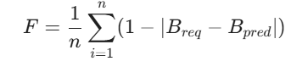
- Warning System: If the calculated alignment falls below a specific threshold (e.g., 0.70), the engine triggers an Automated Warning. The system generates a Cognitive Distribution Chart (Radar Chart) to visually represent the "Fairness Gap" to the educator, highlighting areas where the exam paper is too easy or "out-of-bounds."

4.6 Evaluation
The evaluation of the Automated Pedagogical Fairness Auditing System is divided into three levels: Algorithmic Accuracy, Structural Reliability, and User Utility.

4.6.1 Algorithmic Performance (Bi-LSTM Classifier)
The first level of evaluation measures how accurately the Bi-LSTM classifies exam questions into the six levels of the Revised Bloom's Taxonomy.
- Confusion Matrix: A $6 \times 6$ matrix will be generated to identify specific "confusion" points (e.g., if the model frequently mistakes "Analyze" for "Evaluate").
- Precision, Recall, and F1-Score: Because educational datasets are often imbalanced (with fewer "Create" level questions), we will use Macro-averaged F1-scores. This ensures that the model is penalized if it performs poorly on higher-order cognitive levels.
  - Precision: Measures the accuracy of "Fairness" flags.
  - Recall: Measures the system’s ability to catch all instances of misalignment.
- Baseline Comparison: The Bi-LSTM's performance will be benchmarked against traditional Machine Learning models (e.g., SVM and Naive Bayes) to quantify the "contextual gain" provided by bidirectional deep learning.

4.6.2 Expert-AI Correlation (Fairness Validation)
To validate the "Fairness Score," the system’s output must be compared against the "Gold Standard" of human pedagogical expertise.
- Pearson Correlation Coefficient ($r$): We will calculate the correlation between the AI-generated Fairness Index and the average fairness ratings provided by a panel of three subject matter experts. A correlation of will be considered a successful validation of the system's pedagogical logic.
- Inter-Rater Reliability (Cohen’s Kappa): We will measure the agreement between the AI and human experts to ensure the system's "judgments" are as reliable as a second human auditor.

4.6.3 Structural Integrity (Knowledge Graph Mapping)
The effectiveness of the Neo4j Knowledge Graph in detecting "Out-of-Bounds" content will be evaluated through:
- Path Coverage Analysis: Measuring the percentage of exam questions that the system successfully maps to a specific Learning Outcome (LO) node in the graph.
- Conflict Detection Rate: Evaluating how many "Cognitive Ceiling" violations (questions exceeding the required Bloom level of a module) the system identifies compared to a manually audited baseline.

4.6.4 System Utility & Efficiency
Finally, the system's practical impact on the academic auditing workflow will be measured:
- Time-to-Audit: A comparative time-motion study measuring the minutes required to audit a standard 10-page exam paper manually vs. automatically.
- Expert Feedback (Qualitative): A Likert-scale survey provided to faculty members to assess the "Explainability" of the Fairness Scorecard and whether the automated warnings provided actionable insights for paper revision.

4.7 Ethical considerations
The development and deployment of the Automated Pedagogical Fairness Auditing System will adhere to the following ethical mandates, aligned with the 2024 BERA (British Educational Research Association) guidelines and 2025 AI governance frameworks for higher education.

4.7.1 Data Privacy and Anonymization
The primary ethical concern involves the handling of institutional documents.
- Non-Disclosure: All syllabus documents and exam papers used for system demonstration will be anonymized at the source. Any identifying information, such as instructor names, student-specific feedback, or internal course codes, will be redacted prior to processing by the OCR pipeline.
- Data Minimization: The system will only extract and store "pedagogical metadata" (verbs, nouns, and structural relationships). No personal data related to student performance or individual staff records will be processed or stored in the Knowledge Graph.
- Compliance: The research will comply with the General Data Protection Regulation (GDPR) and the Family Educational Rights and Privacy Act (FERPA) regarding the secure storage and handling of academic records.

4.7.2 Algorithmic Fairness and Bias Mitigation
AI models in education can inadvertently reinforce existing biases.
- Representativeness: The Bi-LSTM model will be trained on diverse datasets spanning multiple academic disciplines (STEM, Humanities, and Social Sciences) to prevent the system from becoming biased toward the linguistic style of a single department.
- Periodic Auditing: The system will undergo "Bias Audits" during the Evaluation phase to ensure it does not unfairly penalize specific question styles or innovative phrasing that may be common in non-technical fields.

4.7.3 Preservation of Academic Autonomy
A critical ethical boundary is ensuring the AI acts as an Assistant, not a Decision-Maker.
- Human-in-the-Loop (HITL): The system is designed to provide "Warnings" and "Scorecards," but it does not have the authority to reject an exam paper automatically. All final pedagogical judgments remain with the human educator and the departmental quality assurance cell.
- Explainability (XAI): To maintain trust, the system will provide "reasoning" for its flags. For example, if a question is flagged as "High Risk," the system will highlight the specific verbs and syllabus nodes that triggered the warning, allowing the educator to understand and contest the AI's logic.
4.7.4 Institutional Trust and Accountability
- Informed Consent: Participation of academic departments in the Case Study phase will be voluntary, with clear communication regarding how the system audits their materials and how the results will be reported.
- Transparency of Findings: All limitations of the AI (such as potential OCR errors or classification inaccuracies) will be clearly disclosed to stakeholders to prevent over-reliance on the automated score.

4.8 Limitations of the study
While the proposed framework utilizes advanced Deep Learning and Knowledge Graph technologies, several constraints inherent to the current research landscape and technical tools must be acknowledged:

4.8.1 Technical and Algorithmic Constraints
- Contextual Ambiguity in Short Texts: Although Bi-LSTM models excel at capturing bidirectional context, exam questions are inherently short. The lack of extensive linguistic features in a single-sentence question can sometimes lead to "semantic drift," where the model may struggle to distinguish between closely related higher-order levels, such as Analyze vs. Evaluate, without broader pedagogical context.
- Data Sparsity for Training: High-quality, human-annotated datasets for Bloom’s Taxonomy are relatively small compared to general NLP datasets. This poses a risk of overfitting, where the model may "memorize" specific action verbs from the training set rather than generalizing the underlying cognitive intent.
- OCR Sensitivity: The accuracy of the fairness audit is heavily dependent on the quality of the input PDF. Low-resolution scans, non-standard fonts, or complex mathematical notations can cause Pytesseract to misinterpret characters (e.g., mistaking "O" for "0"), which may lead to incorrect keyword extraction and subsequent misclassification.

4.8.2 Scope and Generalizability
- Linguistic and Subject Domain: This study is limited to English-language documents. Furthermore, the system may perform with varying levels of accuracy across different disciplines; while it is highly effective for STEM and Social Sciences, it may face challenges in creative arts or highly abstract theoretical fields where cognitive levels are expressed through non-standard terminologies.
- Mathematical and Symbolic Content: The current pipeline focuses on textual analysis. Exam papers in fields like Advanced Mathematics or Chemistry, which rely heavily on symbolic logic and equations rather than "action verbs," may fall outside the current classification capabilities of the text-based Bi-LSTM.

4.8.3 Knowledge Graph Staticity
- Dynamic Syllabus Updates: A Knowledge Graph is a "snapshot" of a curriculum at a specific time. In institutions where syllabi are frequently updated or modules are highly flexible, the graph may require manual maintenance to remain an accurate "Ground Truth" for auditing.
- Cold-Start Problem: The system requires a pre-built graph for every module it audits. The initial effort to digitize and map a new department's syllabus into Neo4j represents a "start-up" cost that may limit immediate scalability across an entire university.
4.8.4 Human-AI Discrepancy
- Inter-Rater Variability: Bloom’s Taxonomy is naturally subjective. Even human experts often disagree on the classification of a specific question. Therefore, the system's "Fairness Score" should be viewed as a decision-support metric rather than an absolute, objective truth.

5.Timeline

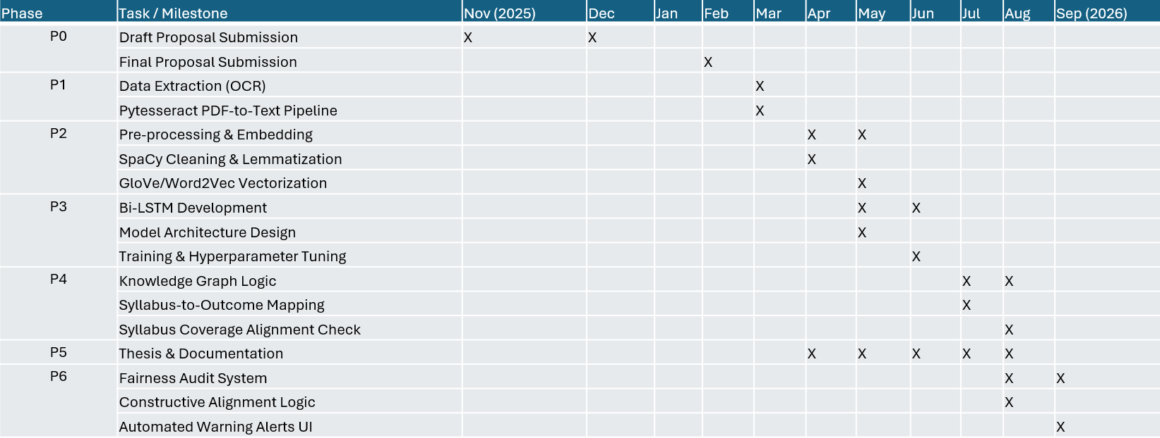

Time duration ( November, 2025 To September, 2026)

References

[1] | J. Biggs, "Teaching for Quality Learning at University: What the Student Does,.," 2nd ed. Buckingham, UK: Society for Research into Higher Education & Open University Press,, 2003..
[2] | L. W. Anderson and D. R. Krathwohl, "A Taxonomy for Learning, Teaching, and Assessing: A Revision of Bloom's Taxonomy of Educational Objectives.New York,," NY: Longman,, 2001.
[3] | S. Ramya Kumar et al., ""Bridging the Cognitive Gap: Automated Analysis of Constructive Alignment in Modern Higher Education,"," J. Educ. Technol. Syst, vol. 53, no. 2, pp. 145-162, 2025.
[4] | V. a. J. D. Dimple, "Use of Common-Word Order Syntactic Similarity Metric for Evaluating Syllabus Coverage of a Question Paper,," vol. 6, no. 2, pp. 68-81, 2014.
[5] | D. V. a. J. D. P. Paul, "“A Syllabus-Fairness Measure for Evaluating Open-Ended Questions.” Advances in Intelligent Systems and Computing Advances in Signal Processing and Intelligent Recognition Systems," p. 57–71, 2014.
[6] | K. B. M. P. I. &. M. D. Jayakodi, "WordNet and Cosine Similarity based Classifier of Exam Questions using Bloom’s Taxonomy.," International Journal of Emerging Technologies in Learning (IJET), vol. 11, no. 4, p. 142, 2016.
[7] | R. e. a. Rekha, " “Ontology Driven Framework for Assessing the Syllabus Fairness of a Question Paper.”," 2012 IEEE International Conference on Technology Enhanced Education (ICTEE), 2012.
[8] | Febriyana, ""Automated Bloom's Taxonomy Classification: Challenges and Opportunities in Machine Learning,"," Int. J. Artif. Intell. Educ., vol. 12, no. 1, pp. 88-102, 2023.
[9] | K. Banujan et al., ""Deep Learning Approaches for Pedagogical Assessment: A Bidirectional LSTM Framework for Bloom's Taxonomy,"," in Proc. IEEE Int. Conf. Adv. Learn. Technol. (ICALT, pp. 214-218, 2023.
[10] | P. M. O. N. Pallegama, K. A. M. R. Kumari, D. M. D. P. M. Dissanayaka, A. V. Y. Ravihansi, A. Karunasenna and U. Samarakoon, "Evaluating Teaching Content and Assessments based on Learning Outcomes," in 2020 2nd International Conference on Advancements in Computing (ICAC), Malabe, 2020.

